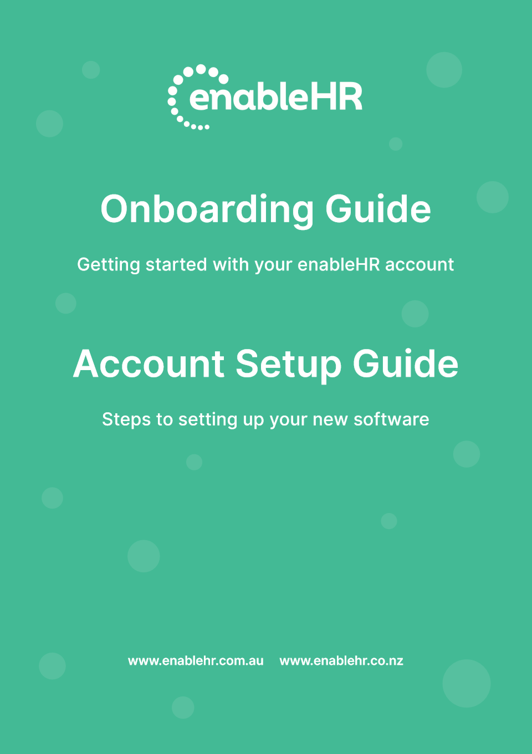

Table of Contents
HR made simple 3
Your journey with enableHR 4
The enableHR onboarding process 5
1. Getting started 8
2. Where to get help 10
3. Important concepts 11
3.1 Employee records and virtual HR folders 11
3.2 Types of users 12
3.3 Branches 13
3.4 Branches to link employees and managers 15
3.5 Company HR documents 16
3.6 Document types 17
3.7 Access control 18
3.8 Access control through User Access Roles 18
3.9 Access roles for core users 18
3.10 Access roles for eSS users 19
3.11 Documents that employees can’t view in the Self-Service Portal 19
3.12 Controlling access using document types 20
3.13 Access control through blacklisting 20
3.14 Alerts 21
4. 7 steps to setting up your account 22
Step 1 – Upload branding files 22
Step 2 – Configure communication 24
Step 3 – Create your branch structure 24
Step 4 – Create or upload employees 26
Step 5 – Upload employee HR documents 28
Step 6 – Upload Company HR Documents 29
Step 7 – Create Manager logins 33
5. Congratulations! 42
6. Consider these add-ons 43

HR made simple
enableHR is cloud-based software that helps you easily manage your employees.
Using workflows and checklists that guide you through smart, legally compliant HR processes, enableHR helps you communicate with your employees and set them tasks. It stores all your employee records and has features that let managers and employees easily access, deliver and receive documents and files at all stages throughout the employee lifecycle. It automates and makes time-consuming HR admin tasks simple, so you have more time to work on the things that matter in your business.
enableHR does this via its comprehensive range of HR and safety modules, which are as follows:

Your journey with enableHR
As a new client of enableHR, you will work through several key phases as part of your journey with us. As you work through each phase, your business will unlock further value.

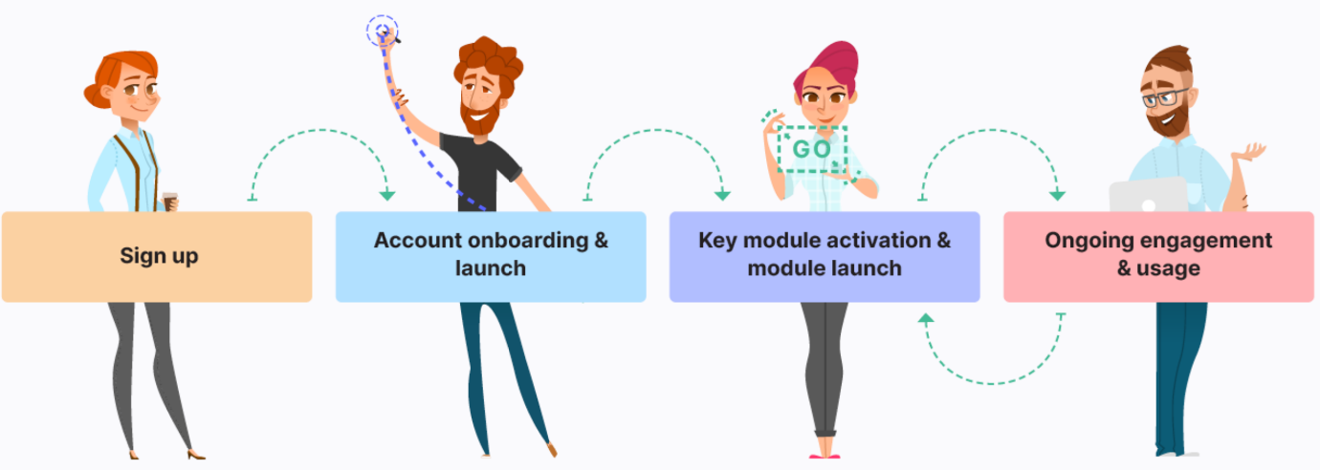

After Signing up to enableHR, you’ll enter the Account onboarding & launch phase which is designed to get you up and running as quickly as possible so that your business can start getting value from enableHR. This phase includes a series of steps to help you set up your account, launch and start using enableHR in a matter of weeks.
You’ll then enter the Key module activation and launch phase which will provide you with the tools to activate and launch your preferred module/s – whether it be enableHR’s Online Performance Review module or the Training & Qualification module, the choice is yours. But to enter this phase, you’ll have to complete the pre-requisite Account onboarding & launch phase first.

How to use this guide
As you’ve probably noticed, this Onboarding & Account Setup Guide contains a lot of information. We have designed it this way so that you have everything you need in the one place – it details exactly what you need to do and in what order. It also ensures you are learning about enableHR’s capabilities in the process of setting up your account.
Sections 1 and 2 provide an overview of the on-boarding process and how to reach out to Client Success if you need support.
Section 3, the most important one, explains the concepts that will help you understand the core system capabilities, how your company’s data and documentation is managed within the system and how user access is controlled. Please do not skip over this section.
Section 4 is where the fun begins and the magic happens. It provides you with step by step instructions and screenshots on how to set up your account.

The enableHR onboarding process
Here, we’ll explain the Account onboarding & launch phase (the phase you are currently in) so you can get started. There are three main stages, shown in the diagram below:

Depending on the size of your organisation and the time you allocate to completing these steps, the entire process can take a few days to a few weeks to complete. The table below is an example of how you can allocate your time to complete each step over three weeks:

TIP:
- You can see that the Account Setup and Communication stages can run in parallel, which is what we recommend.
- Within each stage though, it’s important you execute the steps in the order shown.

Each stage of the process is supported by its own written guide, as well as Knowledge Base articles. The guides are as follows:
- Onboarding & Account Setup Guide (which you’re currently reading) takes you through the basic setup tasks of creating:
  - your branches and branding;
  - your employees in the system;
  - uploading employee HR documents (contracts, letters, etc.); as well as
  - uploading company policies, forms and guides.
Finally, it shows you how to set up the system so your managers can use the Management Portal (also called core enableHR). You’ll learn how to set up permissions so each manager is only able to access the information you allow them to.
- How to Introduce enableHR to Your Team Guide sets out best-practice ways to get your staff excited and ready to start using the system. It includes a recommended process that has been proven to work, as well as a range of communications templates that you can freely edit and use. It also describes the actions you need to take in order to give your employees access to the Self-Service Portal (also called eSS).
- Managers’ Jumpstart Guide is a set of training resources for your managers, to help them start using the Management Portal and managing their staff.
- Employees’ Jumpstart Guide is a set of training resources for employees at every level, explaining how to use the Self-Service Portal to interact with their managers and the organisation.

TIP: Remember enableHR’s Client Success Team as well as your enableHR Partner is here to answer any questions you have.
- You can also purchase an Onboarding Package if you want Client Success to take a more hands-on role to actively help you execute these steps.

Are you ready to get started?

Getting started
This Onboarding and Account Setup Guide will show you how to set up your enableHR account so that it’s branded and reflects the structure of your organisation. It also explains how to create (or import) your employees and existing HR documents, whether the documents are linked to individual employees (such as employment contracts, letters, etc.) or to the company (such as company policies, guides, forms, etc.). Finally, it shows you how to set up the system so that your managers can use the Management Portal (also called core enableHR).
As you can see, this stage sits at the very beginning of the onboarding process, before your managers and employees start using the system.

What this means is that as the enableHR account administrator, you are still the only user in the system and, therefore, the Onboarding & Account Setup is your responsibility! Fortunately, we’ve made this process simple – just follow the steps in the order they’re presented, and you’ll be up and running in no time.

TIP: All actions in this guide must be completed by the enableHR account administrator.

You need to do seven things to set up your account:

Step |  | Description | Timeframe | Effort | Page
1. | Upload branding files. | Set the foundations of your new Human Resources Information System (HRIS), including adding your employees and their existing HR documentation. | Minutes | Week 1 | 21
2. | Configure communication. | Create users for your managers and give them appropriate permissions so they can manage employees. | Minutes | Week 1 | 23
3. | Organise the platform into ‘branches’ that match your organisation’s structure. | Create, update and review communication templates to get your organisation ready for launch. | Minutes | Week 1 | 24
4. | Add your employees to the system. | Train your managers to use enableHR and get them to login and familiarise themselves with the system. | 2-3 hours | Week 1 | 25
5. | Add your employee HR documents. | Invite your employees to log into the self-service portal and learn how to use the system. | 2-3 days | Week 1 | 28
6. | Add your company HR documents. | Use the system to manage your employees and generate legally compliant documentation. | 2-3 days | Week 2 | 29
7. | Create usernames and passwords for your managers. | Create credentials for your managers to access the system and give them appropriate permissions based on their role in the organisation. | 2-3 days | Week 2 | 33

Where to get help
If at any point you become stuck or need help, please contact the Client Success Team or your enableHR Partner. Together, we are here to support you with your new enableHR account.
If you’re in Australia:
Support hours: 8:30am to 5:30pm Monday to Friday
Phone: 1300 453 514
Email: support@enablehr.com
If you’re in New Zealand:
Support hours: 10:30am to 7:30pm Monday to Friday
Email: support@enablehr.com
Phone: 0800 2362 253
From within your enableHR account:  Click on the green 'Help' button in the bottom right-hand corner of the screen and type a few words that describe what you want to know about.  If you can’t find the answers you’re looking for in the list of suggested topics, click on Contact Us to send us a message.  enableHR Business Partner  Partner business name: INSERT  Partner main contact: INSERT  Support hours: INSERT  Phone: INSERT  Email: INSERT | 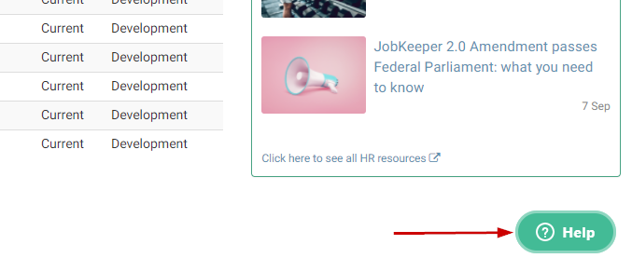

Important concepts
Before setting up your enableHR account, there are a few things you need to know:

3.1 Employee records and virtual HR folders
enableHR is software used to securely manage employees throughout their time at a company.

Employees, candidates, volunteers or contractors in enableHR are represented as an Employee Record. Each Employee Record has its own, secure, virtual HR folder, where all notes, tasks and documents related to that person is stored, whether these items are manually created, uploaded or generated through our checklists and templates.
Notes that are added to the Employee Record can be set to Sensitive.

Employees are not allowed to see sensitive documents and notes stored in their own Employee Record. Document types (see below) are used to make documents invisible to employees.

TIP:
- At this level, we do not make any distinction between employees and their managers (both are technically employees of the business). All you need to know is that each of them has an Employee Record in your enableHR account.
- In the rest of this document, when we mention Employee Record, we’re also including its virtual HR Folder.

3.2 Types of users
For someone to access your enableHR account, they need to be a user, which is the combination of a username and a password.
Because there are two types of people who need to access enableHR (managers and employees), there are also two types of users:

TIP: Restricted means that enableHR stops employees from seeing some sensitive documents and notes that you have added to their record.

There are a few important things to understand:
- Employee Records can only be created by managers (core users) who have been granted the special Employee Management access role (we talk about access roles later here). As the Account Admin, you have automatically been assigned this access role.

- When you create an Employee Record, an eSS user is not automatically created for this employee. You need to explicitly do this. Creating an employee is therefore a 2-step process.

- If the Employee Record you’re creating is for a manager, things are a bit different. You need to create a core user and then link their core user to their Employee Record so that they can access both the Management Portal and the Self-Service Portal using the same set of credentials. Creating a manager is therefore a 3-step process.

TIP: If you don’t want managers to be able to access their own employee records in the Management Portal, you’ll have to blacklist them. We’ll explain later how you can do this here.

3.3 Branches
Branches are how enableHR separates and organises Employee Records. Put simply, branches are set up in enableHR to mirror your organisation’s structure. Branches are central to your enableHR account because they structure the relationship between your managers, your employees and the HR documentation you upload or generate from our legally compliant templates.
enableHR uses two types of branches:
- Legal entity branches are used when the name of the branch needs to appear on documents generated by the system, such as a contract or a letter for instance.

TIP: The top branch (parent company) will always be setup as a legal entity.

- Department / group branches sit below a legal entity and are used to reflect the organisation’s structure. Typically, they represent locations or departments/teams. For instance, "Operations", "Sales", "New South Wales" or "Auckland" would operate under the parent legal entity / company.

TIP: A branch can have an unlimited number of sub-branches. Sub-branches can be linked to one and only one parent branch.

This example from enableHR shows how branches can be set up to reflect the structure of an organisation.  The system is flexible, and although you can easily change things in the future, we recommend that you take the time at this stage to identify, list or sketch out what branches you need to create to best reflect your organisation’s structure. | 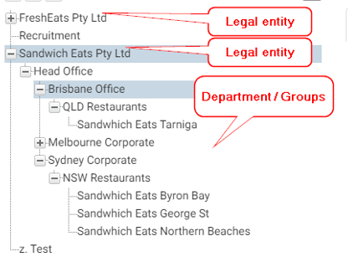

3.4 Branches to link employees and managers
There are two types of people in enableHR:
- Managers are the people who oversee staff through the Management Portal.
- Employees are staff members who interact with their Managers and the organisation via the Self-Service Portal (eSS).

TIP: Managers also have access to the Self-Service Portal as they, too, are employees.
Employees are attached to branches. When a new employee is created, uploaded or imported, you attach them to a Primary Branch. You can later link them to additional branches if you need to.
Managers are given access to one or more branches. They can then see and manage all the employees attached to these branches.

TIP: With the Blacklisting feature, you can prevent a manager from seeing specific Employee Records. You would, for instance, use this feature when you don’t want a manager to access their own Employee Record. We discuss this here.
In the following example:
- Because Manager Chris has access to both “Sales” and “Support” branches, he can see the Employee Records and virtual HR folders of Beth, Adam, Amanda and Andrew.

TIP: To keep it simple, we say that Chris can ‘see’ Beth, Adam, Amanda and Andrew.

- Manager Emma, however, can only access the Employee Records and virtual HR folders of employees attached to the Support branch – she can only ‘see’ Adam, Amanda and Andrew. In fact, Beth, who isn’t attached to Support, won’t even appear in the list of employees that manager Emma can see.

3.5 Company HR documents
Just as individual employees might have historical HR documents that need to be uploaded into their private, virtual HR Folder, you probably also have company documents that you want your managers and employees to be able to access via the Management Portal and/or the Self-Service Portal.
enableHR stores three types of company HR documents:
- Policies – for current workplace policies.
- General Docs – for general workplace documents such as general forms, guides, organisational charts, etc.
- Library & Awards – for any Awards or Enterprise Bargaining Agreements you have.
These documents are stored in a Secure Central Repository. You can restrict who has access to which documents by linking documents to branches.
By default, a document in the Secure Central Repository is linked to all branches in the account, but this link can be limited to specific list of branches. When a document is limited to certain branches, only the managers who have access to one of these branches will see the document.

In the example shown, manager Chris has access to all documents while manager Emma can only access the orange document.

What we have just described for managers is also true for employees: an employee who logs in through the Self-Service Portal (eSS) can only see a Company HR document if this document is linked to at least one branch to which the employee is attached.

In this example, employee Beth can only see the green documents, employee Adam can see all the documents, and employees Amanda and Andrew can only see the orange document. Access is all a matter of which people and which documents are linked to each branch.

3.6 Document types
When you upload documents to enableHR, whether directly in an employee’s virtual HR folder or in the Central Repository, it’s important that you correctly specify what type of document it is (from a drop-down list when uploading it) because the type of document also determines which users can access it.
The most common types of documents, and the portals in which they can be viewed, are listed in the table below. For the complete list, click here.
Type | Typical use | Can be viewed in the Management Portal | Can be viewed in the Self-Service Portal
EC  (Employment Contract) | Used for employment contracts
Letter  (Let) | Used for any HR letter that may be sent to the employee
DOC  (Other Document) | System default, can be used if you don’t want certain documents to be seen in eSS
Email | To log copies of emails that may have been sent outside of enableHR
Policy | Used for any workplace policy
Sensitive | Used for any sensitive HR documentation that only specific users should have access to. | (only users with the ‘Account Admin’ and ‘View Sensitive Notes’ user access roles)
PD  (Position Description) | Used to identify the documents related to PD
Payroll | Used to identify any payroll related material, e.g. payslips | (only users with Payroll document user access)
LVE  (Leave Form) | Used to capture leave forms.
GREV  (Grievance) | Used to track documents related to Grievances | (only users with Payroll document user access)

3.7 Access control
We have already seen that you can use branches to control which employees a manager can see, and which HR documents both employees and managers can see.
There are three other mechanisms that can be used to implement access control:
- User access roles;
- Document types;
- Blacklisting.

3.8 Access control through User Access Roles
User Access Roles determine the permissions granted to users (both core and eSS users). User Access Roles control the types of records and documents users can access, the User Interface tabs they can see and the actions they can perform. This is a complex mechanism and it’s important you spend a bit of time understanding it.
There are many User Access Roles available in enableHR (see here for the complete list) and users can be assigned multiple roles, according to what you want the user to be able to see and do.

3.9 Access roles for core users
The table below shows the most important User Access Roles assigned to core users and whether or not they are assigned by default when a core user is created.
User Access Role | Description | Default
AccountAdmin | Can update the settings of an account, add new users and branches and update user access. | Yes
EmployeeManagement | Can access all features of the Employee Management module. | Yes
ContractorManagement | Can access all features of the Contractor Management module. | Yes
VolunteerManagement | Can access all features of the Volunteer Management module. | Yes
Reporting | Can access the reporting module within the scope of their permitted access. | No
SelfServiceAdmin | Can access to important back end features of the Self-Service Portal, such as eSS messaging for instance. | Yes
AllSelfServiceUser | Standard System Role (DO NOT REMOVE) | Yes
AllEnableHRUsers | Standard System Role (DO NOT REMOVE) | Yes
BulkLaunchChecklists | Can bulk launch checklists and bulk launch tasks within those checklists. | Yes
eSSEmployee | Has standard access to the Self-Service Platform. | Yes
MultiBranch Per Record | Allows the user to link one record to multiple branches | Yes

TIP: There is a range of other Access Roles that are also added by default. They relate to features such as Health & Safety, Position Management, Training & Qualification, etc.

3.10 Access roles for eSS users
The list below shows the most important User Access Roles assigned to eSS users and whether they are assigned by default when the user is created.
User Access Role Name | Description | Default
AllSelfServiceUsers | Standard System Role (DO NOT REMOVE) | Yes
eSS Employee | Standard access for Employees in their Self-Service system. | Yes
WHS eSS | Use this role for workers who need to have access to the new WHS module in eSS. | Yes

As per the table above, eSS users are automatically given the “eSS Employee” access role, which gives them access to some document types. The below table lists the main document types that your employees can view from within their eSS account. For a full list, please see Role Overview – eSS Employee.

Document | Brief Description | Default
EC (Employment Contract) | To identify the employee’s contract in the system | Yes
Agreement | Often used for changes in working arrangements. | Yes
Email | Can be used to log emails that are sent outside of enableHR | Yes
Policy | To identify your workplace policy | Yes
eSS Doc | Any document that you want viewable in eSS | Yes
eSS Form | Any form that you want viewable in eSS | Yes
Others | Document submitted by the employee themselves, for instance those related to Identification, Training, License etc. | Yes

TIP: There are a number of WHS documents that employees can view in the Self-Service Portal in addition to those listed above: WHS Document Types Viewable in eSS.

3.11 Documents that employees can’t view in the Self-Service Portal
Some items will never be visible by employees. These are:
Item | Brief Description
Notes | Unable to view notes added against the employee file by management/HR.
Checklists | Any checklist.
Records | Cannot view other employee records (same applies to contractors or volunteers)
Document types (not listed above) | Can only view document types that are listed above.
Reports | Reporting module cannot be viewed.

3.12 Controlling access using document types
Every document stored in enableHR is assigned a Document Type.
Click here for a list of available document types.
You have the flexibility to control what documents core users can access. This is done by matching Document Types to User Access Roles. In fact, different roles have different document types assigned to them.

TIP: Users with the AccountAdmin role can access all document types.
If a user is not assigned to at least one role allowing access to a document type, then no document of this type will appear to that user.
For instance, users who have been assigned the EmployeeManagement (No access to contracts) will see all document types except for Employment Contracts.
It is very important to carefully select the type of document you upload!

3.13 Access control through blacklisting
Sometimes it’s necessary to prevent a core user from viewing a particular employee record and electronic HR folder, which is what the blacklisting mechanism is used for.
Typically, this would happen when you don’t want a manager to see their own employee record.
You could also want to prevent a core user from seeing some of the employees that are attached to the branches to which the core user has access.
As an example, imagine that you have two managers with access to all the records within the same branch. Suppose that both their employee records are stored in this branch – as they have access to the branch, they will also have access to each other’s record. But you might not want that. This is when you could use the Blacklisting mechanism.

TIP: Blacklisting makes use of employee IDs. This is one of the reasons we asked you to enter Employee IDs when creating your employee records!

3.14 Alerts
Alerts are designed to notify core users of reminders, updates, changes, approval requests, etc., relating to employee records and documents, but also to other types of records like HR checklists, training / license / qualification competencies, incidents and hazards.
Alerts are mostly used to prompt an action, like asking you to upload a document, for instance, but also to notify users that “things are happening”, like the expiry of a licence or an action being completed by an employee.
Users are notified (by email and within the Management Portal) to alerts they’re subscribed to.
Of course, a user will only receive alerts related to employees to whom they’ve been granted access – meaning that a user won’t receive alerts about an employee that belongs to a branch to which the user has no access.
The most used alerts that core users should subscribe to are:

Alert | What does it do?
Employee Alerts | Allows a user to be notified when a note or task is created for action, probation period end dates, etc.
Candidate Alerts | Allows a user to be notified when a note or task is created for action, specific for candidates.
Document Alerts (e.g. expiry) | Allows a user to be notified for document expiry alerts for all documents they have access to, no matter what record.
Training & Qualifications | Allows a user to receive training alerts for all records they have access to; 3-months, 1-month and the day of the expiry.

TIP: Learn more about Alerts here.

7 steps to setting up your account
Now that you’re familiar with enableHR’s core concepts, let’s start setting up your account.

Step 1 – Upload branding files
Personalising your enableHR Management Portal and the Self-Service Portal (eSS) with your company's logo and letterhead helps drive engagement across your workforce and ensures that any documents you generate are branded.
To personalise your brand, you need to upload your company logo and letterhead. We also recommended that you change the email display name to your company name.

TIP: Your letterhead must be in PDF format. Your logo should be in PNG format.
If you use different logos and letterheads for your various legal entities, locations, and teams, you can set up different company branding for each specific account branch (we will cover this in the next step).
In order to upload your logos and letterhead, take the following steps:
- Click Settings in the top menu and then click Account Settings. | 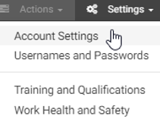
- Click Branches and then click the branch. Click Branding and then click Edit. | 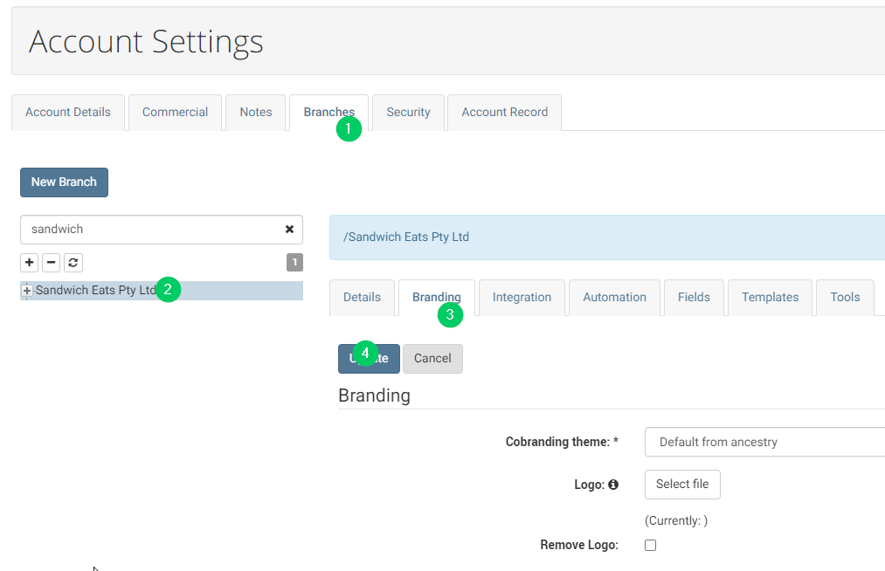
- Select a logo file for the Management Portal. | 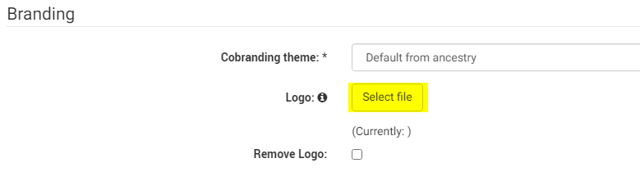

TIP: For best results use a logo no larger than 400 pixels wide by 100 pixels tall (400x100). We recommend PNG format as this provides the highest quality.

- Select a PDF file for your Letterhead. | 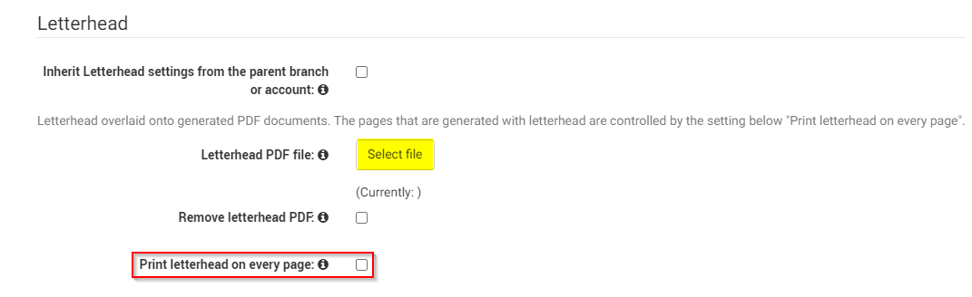

TIP: By default, your letterhead will only appear on the first page of your documents. If you would like it to be visible on all pages, select 'Print letterhead on every page'.
- Click Update to save your changes. | 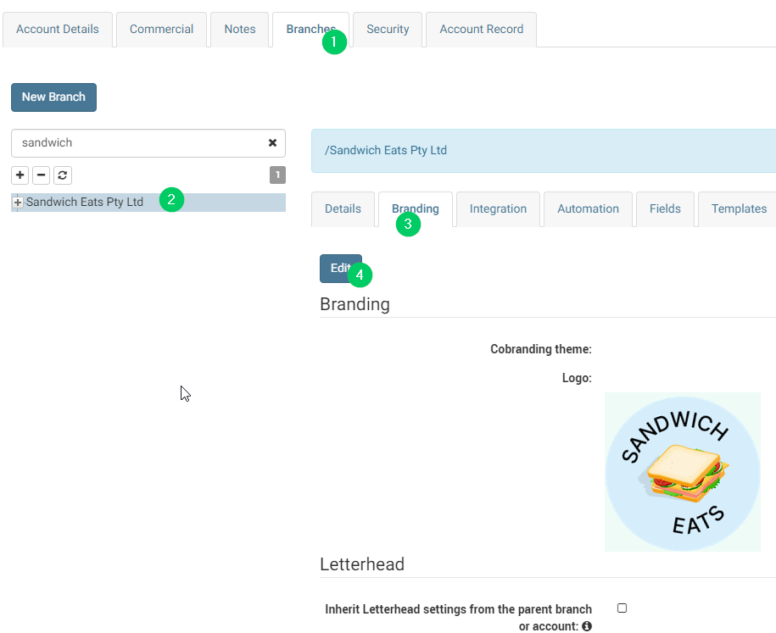
Sometimes your letterhead might not look right, and you may need to adjust the margin spacing. Within the Branding tab of your branch, click Preview Template and select the document template you wish to preview.
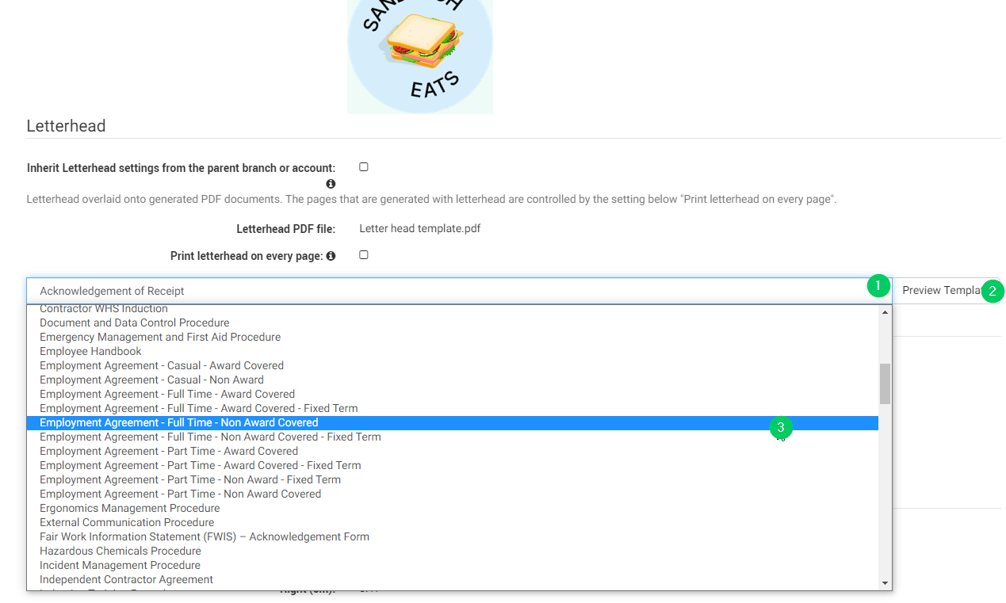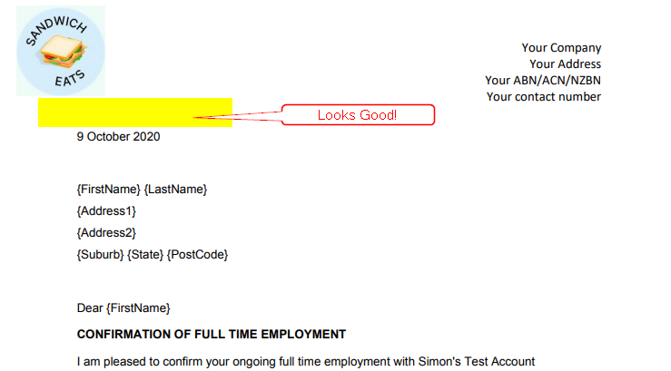
If you need to fine tune the margin spacing, click on Edit and use the Margins - Pages with Letterhead and Margins - Pages without Letterhead sections. Adjust the margins until you are happy with the way your letterhead displays.

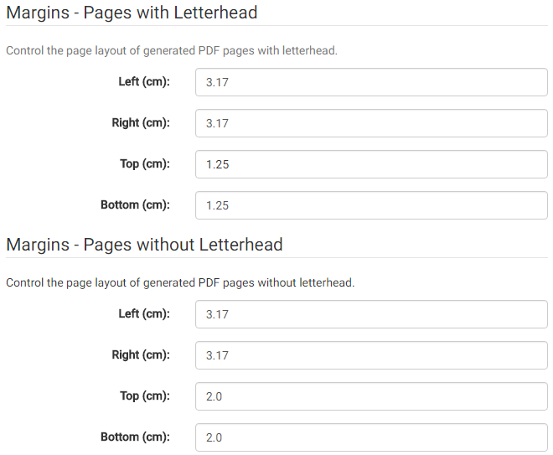

Step 2 – Configure communication
Emails sent from enableHR use the default From field which is set to enableHR. You should change the email display name to your company name, so recipients recognise the email is coming from your business.

- Click on Settings in the top menu.
Click on Account Setting.

- Go to Account Details, click Communication and click Edit. | 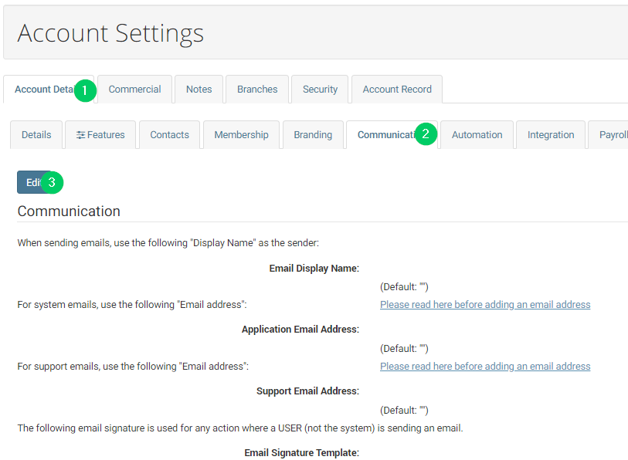
- Enter in an Email Display name, Application email, support email address and email signature. Click Update to save your changes. | 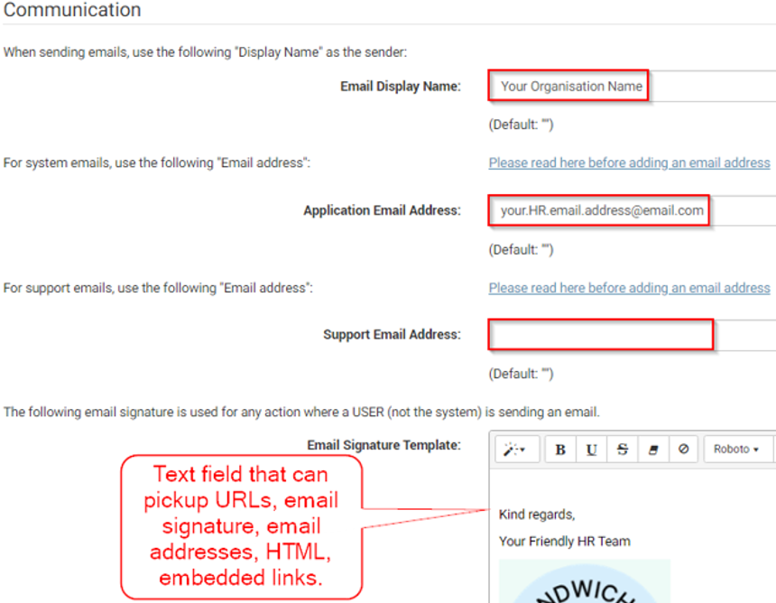
- Here’s how an example email, sent via enableHR, displays based on the details entered within the communication settings. | 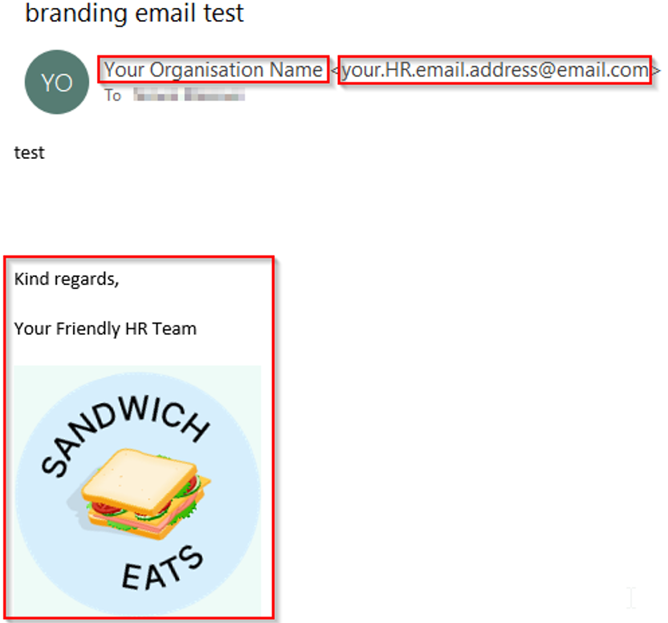

TIP: Ensure that your network Sender Policy Framework is setup to whitelist emails sent from the enableHR system, for instructions on how to do this refer to: this article

Step 3 – Create your branch structure
- Click Settings in the top menu,
then click Account Settings.

- Go to Branches and then  click New Branch. | 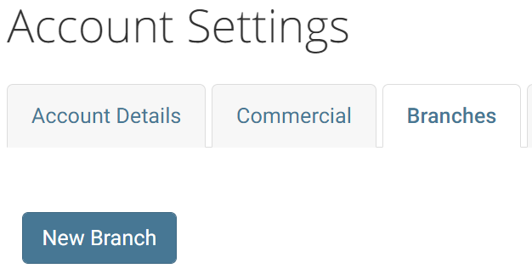
- Pick the type of branch and complete the fields. If creating a sub-branch, make sure the Parent Branch is selected. | 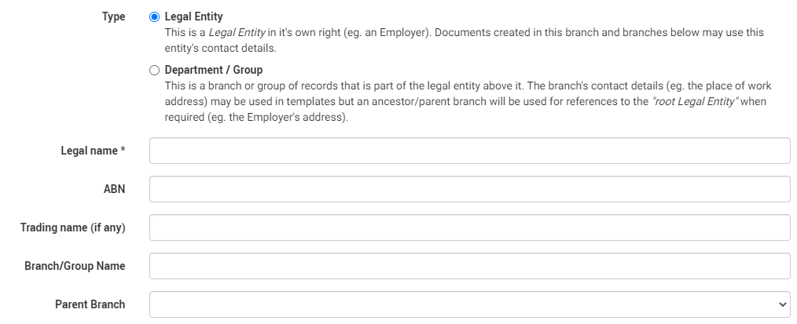
- Select Give access to all existing users to add this new branch to your user access, then click Create. | 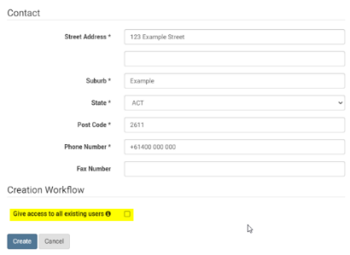

TIP: If you don’t check the Give access to all existing users box while creating the branch, you will need to update this later.

- Once the branch is created, you should set an Integration API Key. To do this,  go to the Integration tab, click Edit  and Update. | 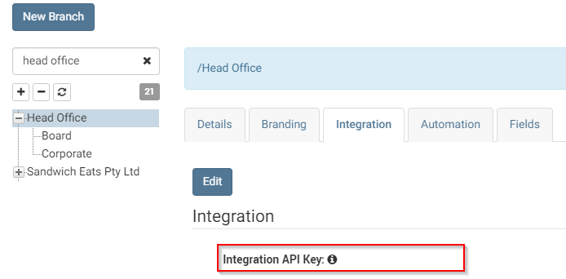
 | TIP: The branch API key acts as a unique identifier to help the application designate and identify a branch. It can be any combination of numbers and letters. This branch API key is vital for importing employees and API integrations. If a branch doesn’t have an API Key, then it will not be possible to import employees into it.

Step 4 – Create or upload employees
To ensure that your workplace and HR management processes are integrated with enableHR, you need to add your current employees. You can manually create them one by one, upload them in bulk via the Excel importer, or import them using payroll integration (if available).

TIP:
- When preparing your employee data, you need to ensure that each employee has an email address. This is a prerequisite to launching the Self-Service Portal (eSS) later in the on-boarding process.
- We recommend that you assign every employee a unique employee ID number. For consistency, it is recommended that you use the same employee ID number stored in payroll (if applicable). Employee IDs are necessary for future automation when it comes to things like automating bulk actions, such uploading existing HR documents.

How to manually create an employee
- Go to the Employee Management module.
Select Employees and click on the Add Employee button.
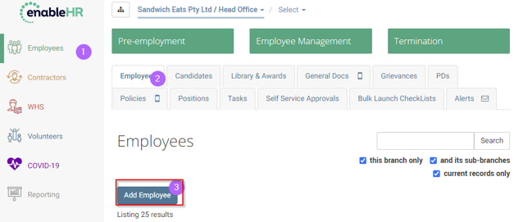

- Fill out all available fields for the  new employee. | 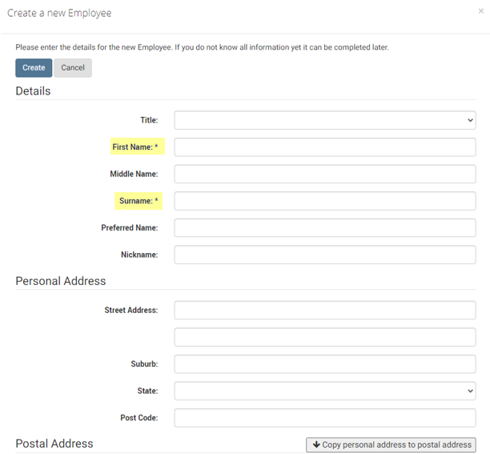
- Don’t forget the E-mail address! | 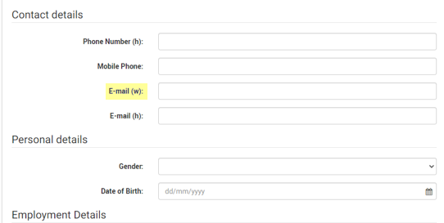

TIP: Without an e-mail address, your employee can’t access the Self-Service Portal or receive enableHR-generated emails.
- Add an Employee ID number.  When you’re all done, click Create. | 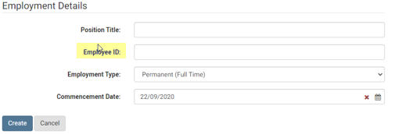

TIP: Don’t forget the Employee ID if you want to be able to upload documents in bulk and access other powerful features of the system.

How to upload employees in bulk using the Excel importer
This is an advanced feature which we only recommend if you have more than a few employees to upload.
- Click here for more information on how to upload your employee records in bulk via an Excel spreadsheet.

How to import employees using payroll integration (if available)

Please refer to the relevant guide/s below for step-by-step instructions on how to import your employees through payroll integration:
- Xero Guide (required fields: the employee first name, last name, and DOB/Post code to link the employee records between enableHR).
- Meridian Guide (required fields: the employee last name, employee ID number and Paypoint/Location to link between enableHR and Meridian/MicrOpay).
- Wage Easy Guide (required fields: employee ID number).
- MYOB Guide (required fields: employee ID number).

TIP: Payroll integration is an advanced feature. Talk to Client Success or your enableHR Partner if you’re not sure about the process or need some assistance.

Step 5 – Upload employee HR documents
When you added your current employees to enableHR, a virtual HR folder was automatically created for each of them. Each of these folders needs to be populated with up-to-date HR documentation on the employee’s employment history.
It may be tempting to skimp on this step and not upload everything – after all, it’s one of the most time-consuming parts of the initial setup – but uploading every document you can is vital! Complete employee records are necessary for your leadership and management teams to be appropriately informed on all staff matters when managing their employees, as well as a legal requirement when it comes to compliance.

TIP: Uploading all employee documents may be a daunting task due to the large volume of documents you may have on file. We recommend you do it in phases and focus on the critical documents first. These include signed employment contracts, signed workplace policies, HR letters relating to current HR issues, copies of license identification and visa documentation.

How to manually upload an HR document
- Go to the Employee Management module, select Employees and then select the relevant employee. | 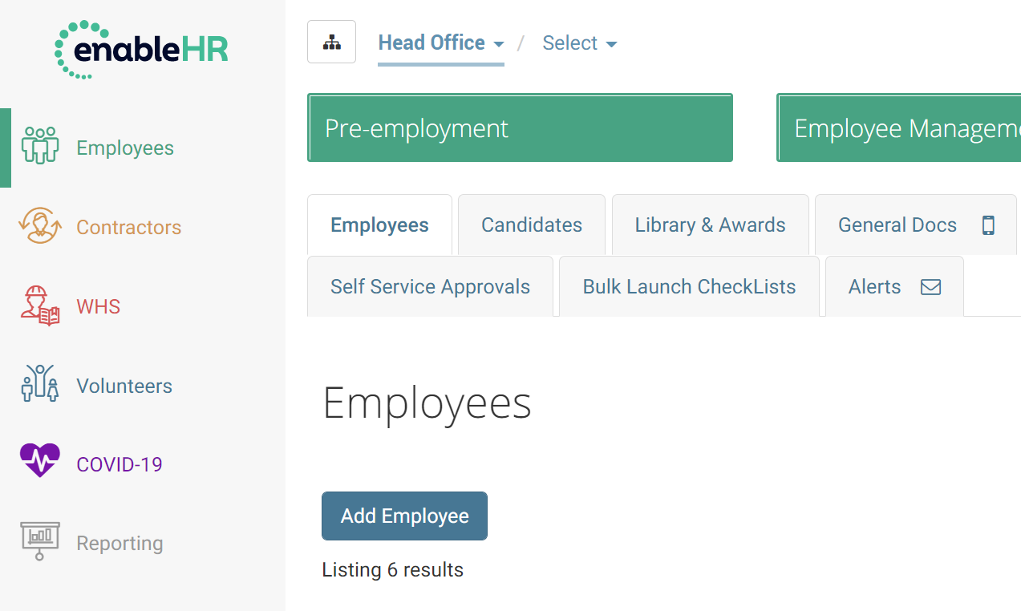
- Go to Documents and select  Upload a new document. | 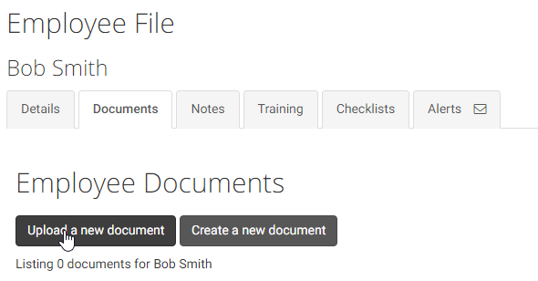
- Fill out all the available fields and  click Upload. | 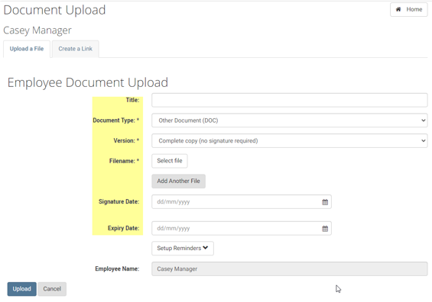

TIP: TIP: Remember to correctly select the Document Type, because this is how you can later control user access. For the complete list, click here.

How to upload HR documents in bulk (advanced)
With enableHR, you can bulk upload all types of employment documentation, such as contracts, important HR letters and copies of licenses and qualifications. These will be automatically saved to each employee according to their unique employee ID (aren’t you glad you entered all those employee ID numbers earlier?).
There are a couple of ways to upload your employee documents in bulk. The following article covers the most straight-forward approach:
How to upload in bulk a set of documents of the same type to multiple records

TIP: Again, make sure to select the correct Document Type. For the complete list,
click here.

Step 6 – Upload Company HR Documents
This step adds your company HR policies and documents to your account, so that your leaders, managers and employees can access all HR related documents via enableHR. Having these documents accessible in the system (especially if they’re only accessible in the system) is a good way to get people to consistently use the new software.
Your HR documentation should be stored under one of the three categories in the Employee Management module:
- Use the Policies location for copies of your current workplace policies.
- Use the General Docs location for copies of your general workplace documents (such as general forms, guides and organisational charts, for example).
- Use the Library & Awards location for copies of any relevant Awards or EBAs, for example.

TIP: The Policies and General Docs tabs have a mobile icon pictured next to them. This means that all Created, Completed or Executed documents in these tabs can be accessed by your employees through the Self-Service Portal (eSS).

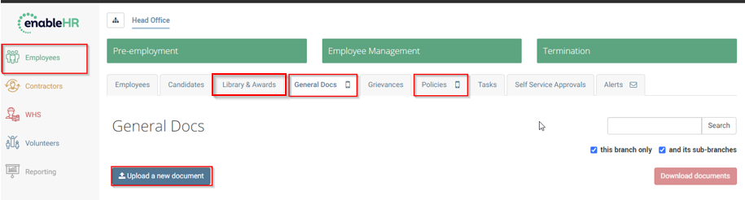
There are three ways to add your documents to enableHR:
- Upload your documents manually.
- Link documents to external files on your intranet or the internet.
- Generate and customise new workplace documents and policies using our employment law policy templates (which are regularly reviewed and updated by our Law partners).

How to manually upload policies and HR documents
- Go to the relevant tab (Policies, General Docs or Library & Awards). Click on Upload a new document. Click Select File. Pick the document(s) to upload. | 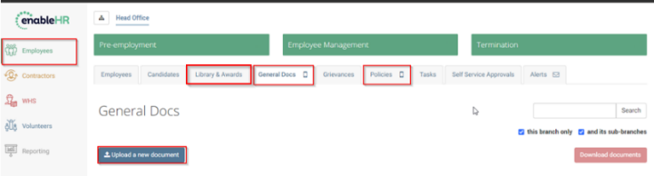
- Fill out the available fields. Click Upload or restrict the document to specific branches (step 3) if required.  TIP: Remember to correctly select the Document Type because this is how you can later control user access. The most common types are listed in the table below. For the complete list, click here. | 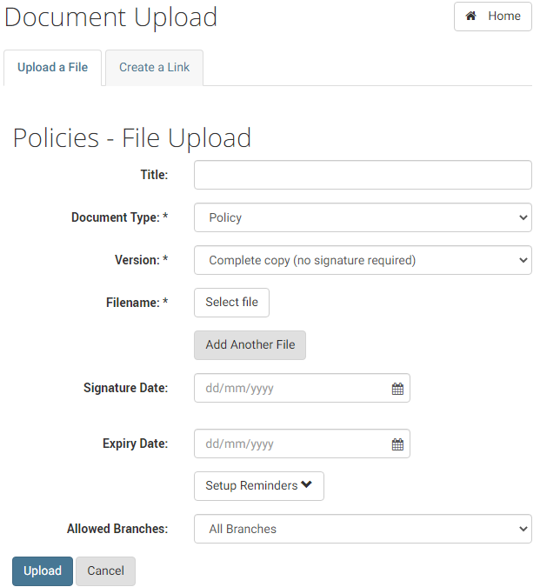
By default, access to the document is granted to all branches. Only carry out the following steps, 3 & 4, if you want to restrict access to specific branches.

- Select the Allowed Branches field, then Selected branch(es). | 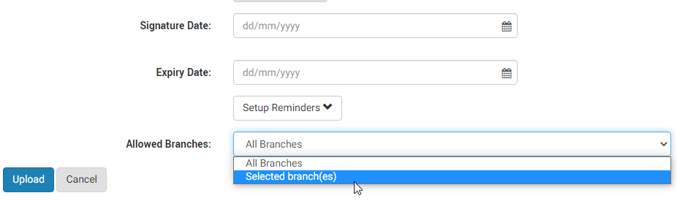
- Select all the branches you want to link the document to and  Click Upload.  TIP: By default, the uploaded document can be viewed by all branches. | 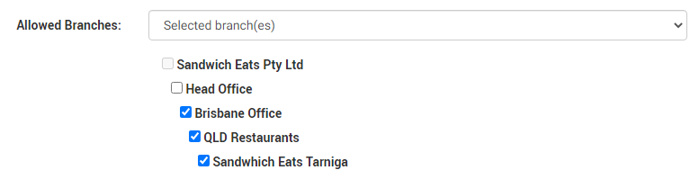

How to link documents to external files
- Go to the relevant tab (Policies, General Docs or Library & Awards).  Click Upload a New Document and then click Create a Link. |  | 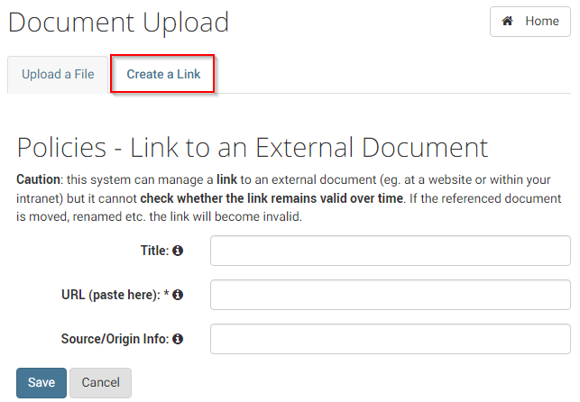
- Add the Title, URL and a short description for the Source/Origin Info. Click Save.  TIP: enableHR only accepts valid HTTP or HTTPS web addresses. Some examples of correct web address formats: http://enablehr.com.au/test.pdf or https://enablehr.com.au/test.pdf |  | 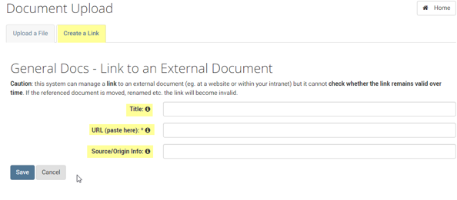
By default, access to the link/document is granted to all branches. Only carry out the following steps, 3 & 4, if you want to restrict access to specific branches.

- Select the Allowed Branches field, then Selected branch(es).

- Select the branches you want to link the document to and
Click Update.

TIP: By default, the uploaded document/ link can be viewed by all branches.

How to generate a new workplace policy from one of our legal templates

TIP: When you create a policy document using one of our templates, it is automatically stored under the Policies tab.
- Go to Policies. Click Create a new policy. Select the relevant type of policy. Click Next. | 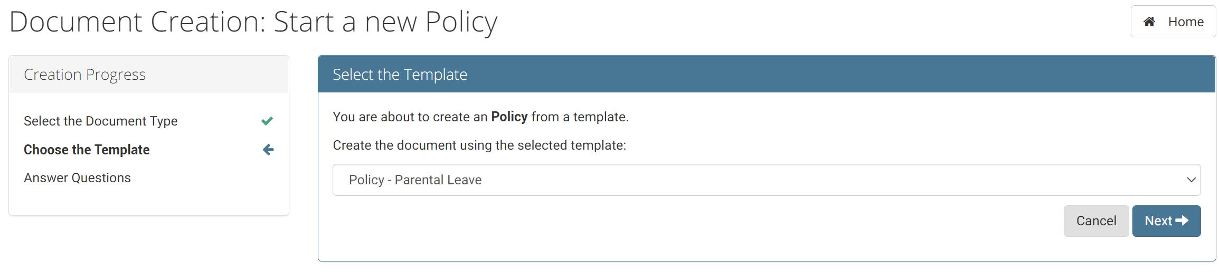
- Go through the question-and-answer process to align the policy to your organisation. | 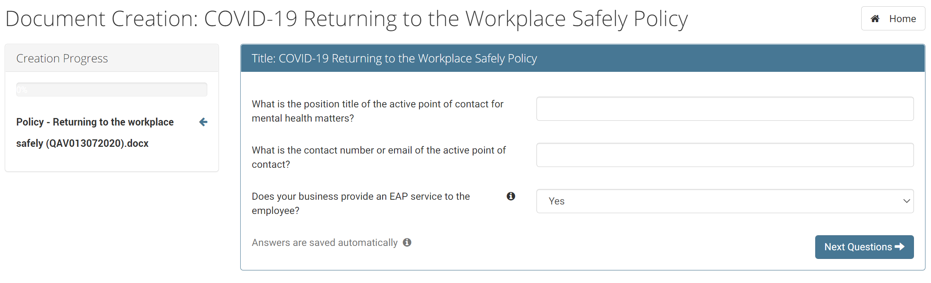
- Click on Edit to review and amend your answers (if necessary). | 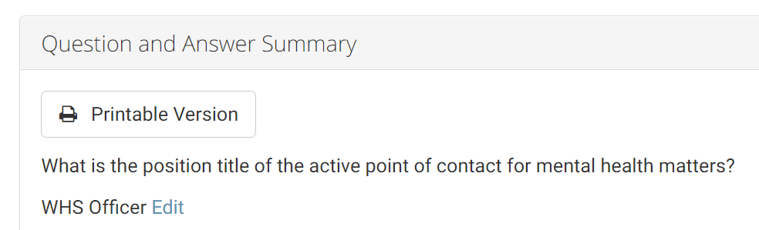
- Click on Preview (to preview the document before creating it) or the Create button (which gives you the option to create it as a Microsoft Word or PDF document). | 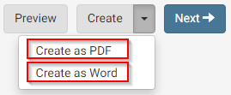

TIP: Creating a policy as a Word document allows you to amend the policy before you finish creating it. For more information on the Amend in Word process,
click here.
- Click on Edit to review and amend your answers if necessary.
- Click on Next to finish creating  the document. | 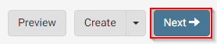
- In the next screen, you can then Download the Document or Amend the Document (if you have created it as a Word document). | 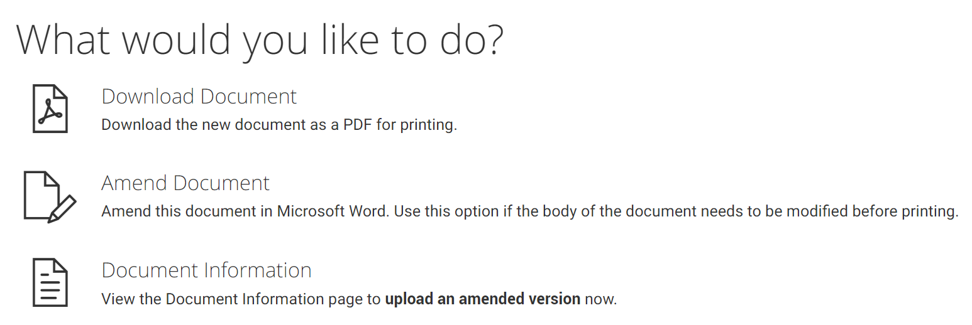

Step 7 – Create Manager logins
You create a core user account for each person who needs access to the Management Portal.
The following flowchart identifies the steps you need to take:

TIP: Only users with the AccountAdmin access role can create and manage core users.

- Click on Settings in the top menu. Click on Usernames and Passwords. | 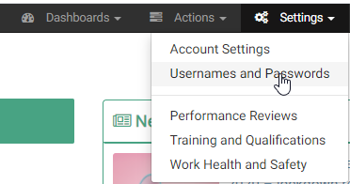
- Click on Users. Click on New User. | 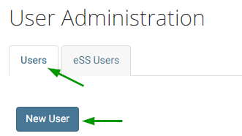
- Enter a Username that is unique to the account. We recommend using an email address or a combination of first and last names. | 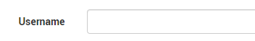
- Enter a temporary password that the user will use when first logging in. | 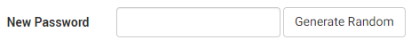

TIP: Login credentials are not automatically sent to users, so make sure you copy the password so you can send it later.
- Enter as many of the available fields as possible. Tasks will always be sent to Contact Email. Alerts will also be sent to Contact Email, unless there is a different Alert E-mail entered. | 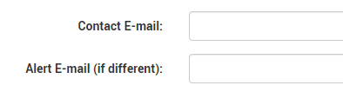
- Make sure the Password Expired checkbox is ticked so that the user must choose their own password when they first log in.  The Self-service only option allows you to create a user that can only access the self-service portal, not the core enableHR platform. These users are not allowed to log into the Management Portal. Make sure this option is not selected when creating a core user. | 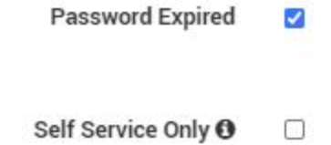
- Tick the Opt-in to Mailing List checkbox to ensure the user receives regular communications from enableHR such as, newsletters, legal updates and system updates. | 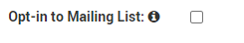

TIP: Make sure to tick this box for all Account Administrators so you can send it later.
- Click Create to create the user profile. You can always come back to this process and update any information for this user.

IMPORTANT: enableHR does not automatically email login credentials to new users. There are other steps you need to take before they can log in. Our guide on how to introduce enableHR to your team includes communication templates that you can use for this purpose.

Link the core user to their employee record
If your newly created user is also an employee, you need to link them together.
Read about linking here.

- Click on Settings in the top menu. Click on Usernames and Passwords. Select the relevant user.

- Go to Access Control. Click on Linked Record. Click on Edit. Select the employee.
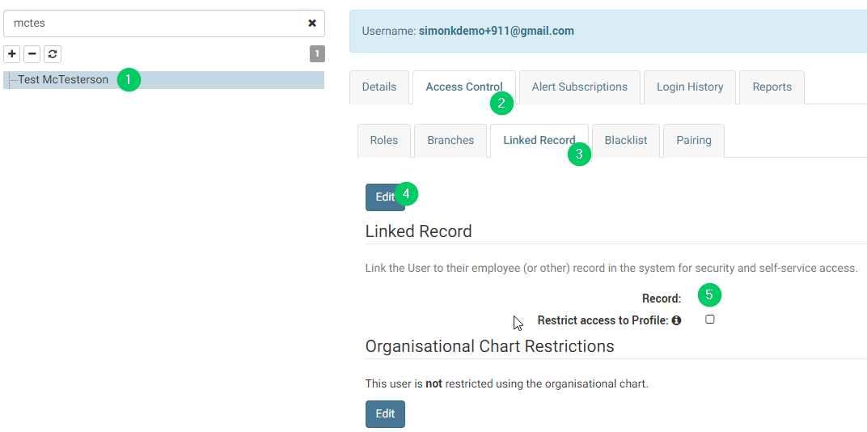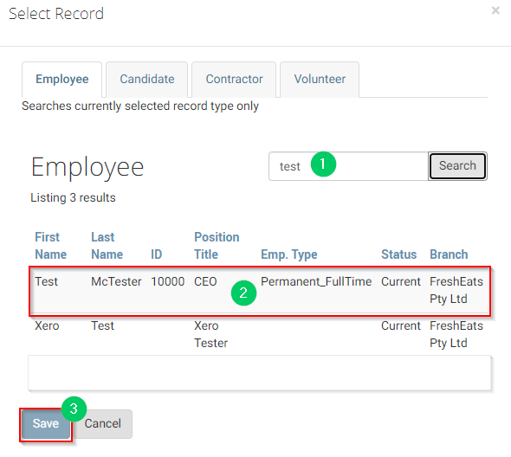

- Tick the Restrict access to Profile checkbox and click Update. | 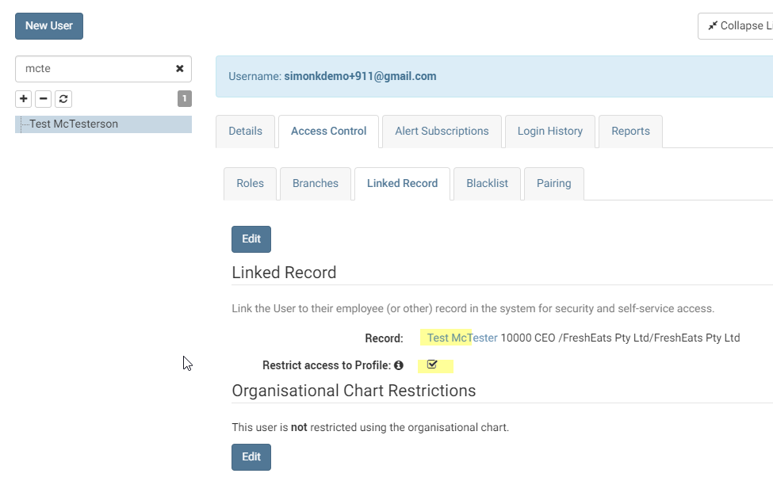

How to blacklist an employee record for a core user
Read about blacklisting here.

TIP: Only users with AccountAdmin access role can execute this action. You will need the Employee ID of the employee record to do this.

- Click Settings in the top menu. Click Usernames and Passwords. Select the relevant core user.

- Go to Access Control. Click Blacklist. Click on Edit. Type in the employee ID numbers of the employee records that you do not want the core user to access. | 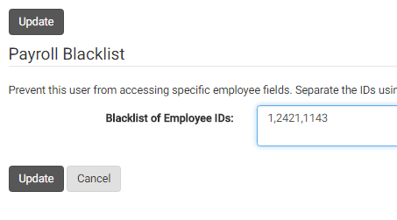
- Click on Update and check that the results show the correct employees. | 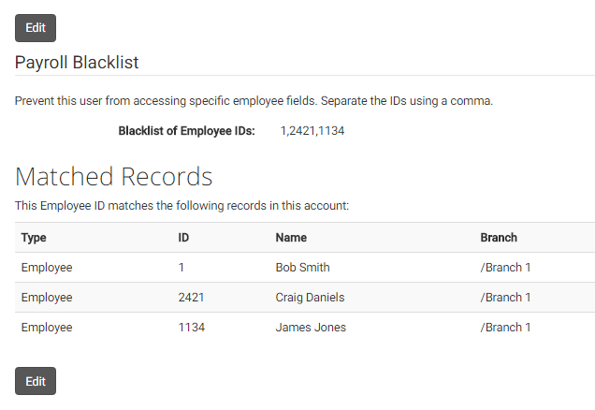

How to review and update user access to branches
Users need to be granted access to the branches that they have permission to view. For example, line managers in different departments may be responsible for maintaining their employees’ files, but shouldn’t be able to view the files of employees in other departments. In this case, each user will need to have the appropriate branch assigned to ensure appropriate access.
Read about branches here.
- Click on Settings in the top menu.
Click Usernames and Passwords.
Select the relevant user.

- Go to Access Control.  Click Branch. Click Edit. | 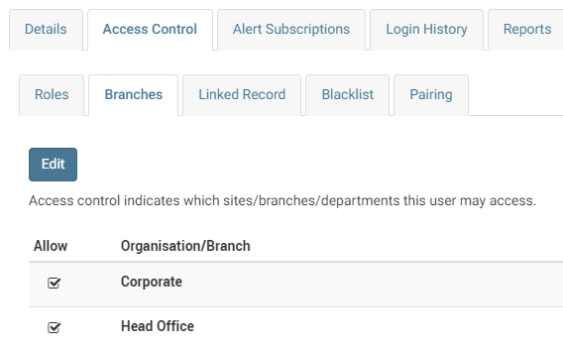
- Select the relevant branches you want the user to be able to access.  Click on Update. | 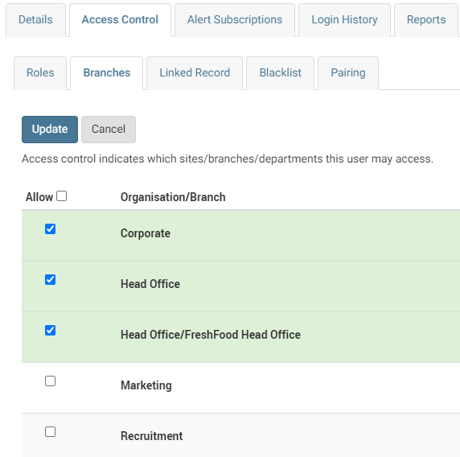

How to review and update user access roles
enableHR users have access roles assigned to them which dictate what aspects of the system they can access.
Users can be assigned one or multiple roles. For example; an HR manager, for example, would be assigned all of the standard roles, whereas a user who doesn’t have security clearance to view personnel files, but is responsible for entering in WHS details, would be assigned the WHS management user role and would not able to view anything else.
Read about access roles here.
- Click Settings in the top menu.
Click Usernames and Passwords. Select the relevant user.

- Go to Access Control. Click Roles.  Click on Edit. Select the relevant roles.  Click on Update. | 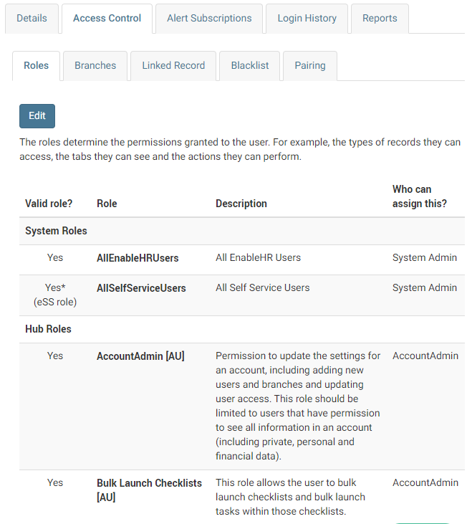

If you’re unsure about what type of access you should provide to different types of users, we’ve made it easy for you. Below is a list of common access types for the following levels of access: account administrators (highest level of access), a typical manager (usually senior manager), a restricted manager (usually team leaders) as well as a typical employee. If you’re still not sure, contact the Client Success Team or your enableHR Partner for guidance.

Example: account administrator user access
The following access roles are recommended for users who are required to set up and launch all enableHR modules. They also give permission to update the settings of your enableHR account. This includes the creation of new users and new branches, and includes permissions to update user access and branch details. Generally, only a handful of users should have account administrator access.

User Access Role Name | Brief Description
AllEnableHRUsers | Standard System Role (DO NOT REMOVE)
AllSelfServiceUsers | Standard System Role (DO NOT REMOVE)
AccountAdmin | Can update the settings for an account, including adding new users and branches and updating user access. This role should be limited to users that have permission to see all the information in an account (including private, personal, and financial data).
Bulk Launch Checklists | This role allows the user to bulk launch checklists and bulk launch tasks within those checklists.
ContractorManagement | Grants the user access to all features of the Contractor Management module within the account. Important Information: this role is assignable by an Account Administrator. Once assigned, the user granted the role will have access to the Contractor Management module.
EmployeeManagement | Access to all features of the Employee Management module within the account
eSS Employee | Standard access for Employees in the Self-Service system.
Position Management | This role will allow users to access the features which the Position Management module allows. Users assigned this role will have access to two distinct record types: Positions and Position Candidates.
SelfService Admin | Access to the Staged Records Approvals and Self-Service Messaging options for Self Service
TrainingManagement | Users with this role have access to the training and qualifications features within their account.
VolunteerManagement | Access to all features of the Volunteer Management module within the account Important Information: This role is assignable by an Account Administrator. Once assigned the user granted the role will have access to the Volunteer Management module.
WHS Administrator | Use in addition to the WHS Management role. Provides access to all the features of WHS. This role is for users who manage WHS for the organisation as a whole.
WHS Approver | Assign this role to enableHR users who have authority to approve WHS Policies and other processes. Usually this role would be given to an “officer”.
WHS eSS | Use this role for workers who need to have access to the new WHS module in eSS.
WHS Management | Provides access to the WHS module. Best suited for a manager, site manager, team leader.
WHS Notification | Users with this role will receive notification when new hazards or incidents are submitted via eSS. Note: you need to have access to a branch to be notified about incidents or hazards related to that branch.

Example: typical manager user access
The following access roles are recommended for users who need to manage employees who report directly to them. They should be able to undertake most of the activities against the employee. For example, this type of user should be allowed to create a new employee, upload new HR documents and/or track HR notes.
Note that manager users are typically only given access to the branches to which their directly-reporting employees belong. For example, the Sales Manager should have access to all sales staff in the Sales branch.

User Access Role Name | Description
AllEnableHRUsers | Standard System Role (DO NOT REMOVE)
AllSelfServiceUsers | Standard System Role (DO NOT REMOVE)
EmployeeManagement | Access to all features of the Employee Management module within their account.
eSS Employee | Standard access for Employees in their Self-Service system.
WHS eSS | Use this role for workers who need to have access to the new WHS module in eSS.
ContractorManagement | Access to all features of the Contractor Management module within their account.
VolunteerManagement | Access to all features of the Volunteer Management module within their account.

Example: manager with restricted access
Similar to the ‘typical manager access’ example, the following access roles are recommended for users who need to manage and undertake most activities against the employees that report directly to them as their Manager. These users are, however, restricted from viewing any sensitive or private HR documentation. Of course, their access should also be to the branches in which their employees sit. For example, the Sales Manager should have access to all sales staff in the Sales branch.

Start by assigning the following general access roles:
User Access Role name | Description
AllEnableHRUsers | (DO NOT REMOVE) Standard System Role
AllSelfServiceUsers | (DO NOT REMOVE) Standard System Role
eSS Employee | Standard access for Employees in their Self-Service system.
WHS eSS | Use this role for workers who need to have access to the new WHS module in eSS.

Then, restrict visibility by assigning the relevant access roles:
User Access Role Name | Description
EmployeeManagement-  (No Docs or Notes) | (CHOOSE 1) Reduced access to the Employee Management module within the account, but no access to Candidate/Employee Documents Tab or Notes Tab.
EmployeeManagement-  (No Docs, Notes or Checklists) | (CHOOSE 1) Reduced access to the Employee Management module within the account, but no access to Candidate/Employee Documents Tab, Notes Tab or Checklists Tab.
EmployeeManagement  (No access to contracts) | (CHOOSE 1) Access to all features of the Employee Management module within the account, except for Employment Contract(s).
EmployeeManagement  (View only access to Policies, General Docs & Library tabs) | (CHOOSE 1) Normal access to the Employee Management module, however ‘read only’ access to the “Policies”, “General Docs” and “Library & Awards” tabs.

Congratulations!
You’ve finished the setup of your enableHR account!

By now you should also have started, and hopefully completed, the communication stage. Please contact your enableHR Partner if you need support with this process.
It’s time to move to the next step: training your managers and employees and launching your new HR software!

TIP: To launch enableHR, read this guide: How to introduce enableHR to your team.

Consider these add-ons

Train the Trainer
Now that you’ve set up your market-leading HR software to help you manage your workforce and ensure your business is compliant, it’s time to start getting your team excited about using it! Training your staff is an effective way to demonstrate how the software works and, most importantly, how it will help each individual manage their people and easily carry out the HR tasks relating to their role. Please refer to the Launch Guide for more detailed guidance on how to successfully launch your new software.
To ensure that the training of your staff is successful (meaning each key user group within your business has a clear understanding of what they can do within enableHR and know when and how to use it), the account administrators within your business need to first become experts on enableHR.
To help with this, enableHR offers dedicated training for account administrators. The training will enable you to go on to train your leadership team, managers and employees as part of your launch strategy.
Should you wish to arrange for some training, please contact the Client Success Team detailing your specific training needs. We’ll give you a quote and arrange a suitable time. Training is generally conducted in a series of webinars that run between 2-4 hours for each session, with around 2 – 6 people normally in attendance. The live training is conducted via ZOOM and can be recorded for your future reference.

TIP: For an insight on a typical training package for new clients, click here: Training Package.

Customise your account to your business’s needs
While enableHR provides you with smart, legally compliant HR processes, we recognise that your business is unique and you will have your own way of doing things.
enableHR can work with you to customise your enableHR account to work with your unique processes and templates. A customised account provides an even greater return on investment as you reap the rewards of a purpose-built tool specific to your industry and organisation.
The following items in enableHR can be customised to suit your business’s needs:
- Templates (Contracts, Letters, Policies, Guides, and/or other documents)
- Checklists and Menu Items
- Tabs
- Custom Fields
- Note Categories and Topics
- User Access Security Roles
Please note that customised checklists and templates will not be regularly reviewed by our employment lawyers. For this reason, we recommend to only customise processes or templates in enableHR that are significantly different to your preferred way of doing things.

How is enableHR customised?
enableHR's Implementations Team (working together with your business and your enableHR partner) will configure the platform for you. They’ll work with you to identify your needs prior to building and customising your enableHR account. This is a cost-per-hour service, so the final cost depends on the scope of the project. Once we’ve worked with you to define the scope, we’ll supply you with a quote for you to approve and sign before we start work.
For an understanding on how to approach the configuration process, please see our article: What factors should be considered when seeking enableHR customisation?



